SUMIF_Store data:

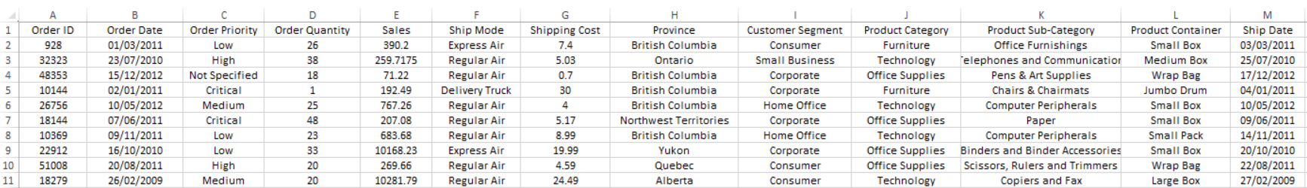

Ontario Total Sales: =SUMIF(StoreSalesTable[Province], "=Ontario", StoreSalesTable[Sales])

Furniture Total Sales: =SUMIF(StoreSalesTable[Product Category], "=Furniture", StoreSalesTable[Sales])

